Dev: AbebeAbitew
Date:04/12/2026
Course: BIDD 330Assignment 1

Link to the Power Bi Services:
https://app.powerbi.com/groups/777f92d5-bef3-4145-92de-7ca2a66d192b/list?experience=power-bi

- Relationship among Tbales
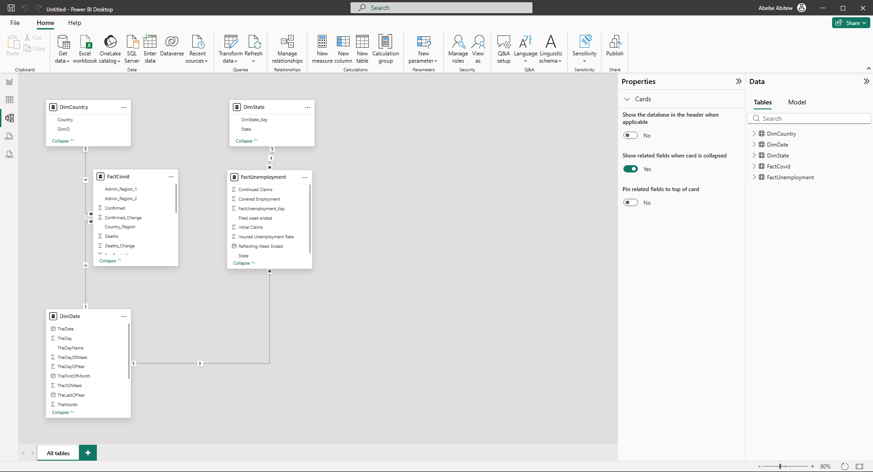

- Final Power Bi Visualization and ready to be published ( Screenshot)
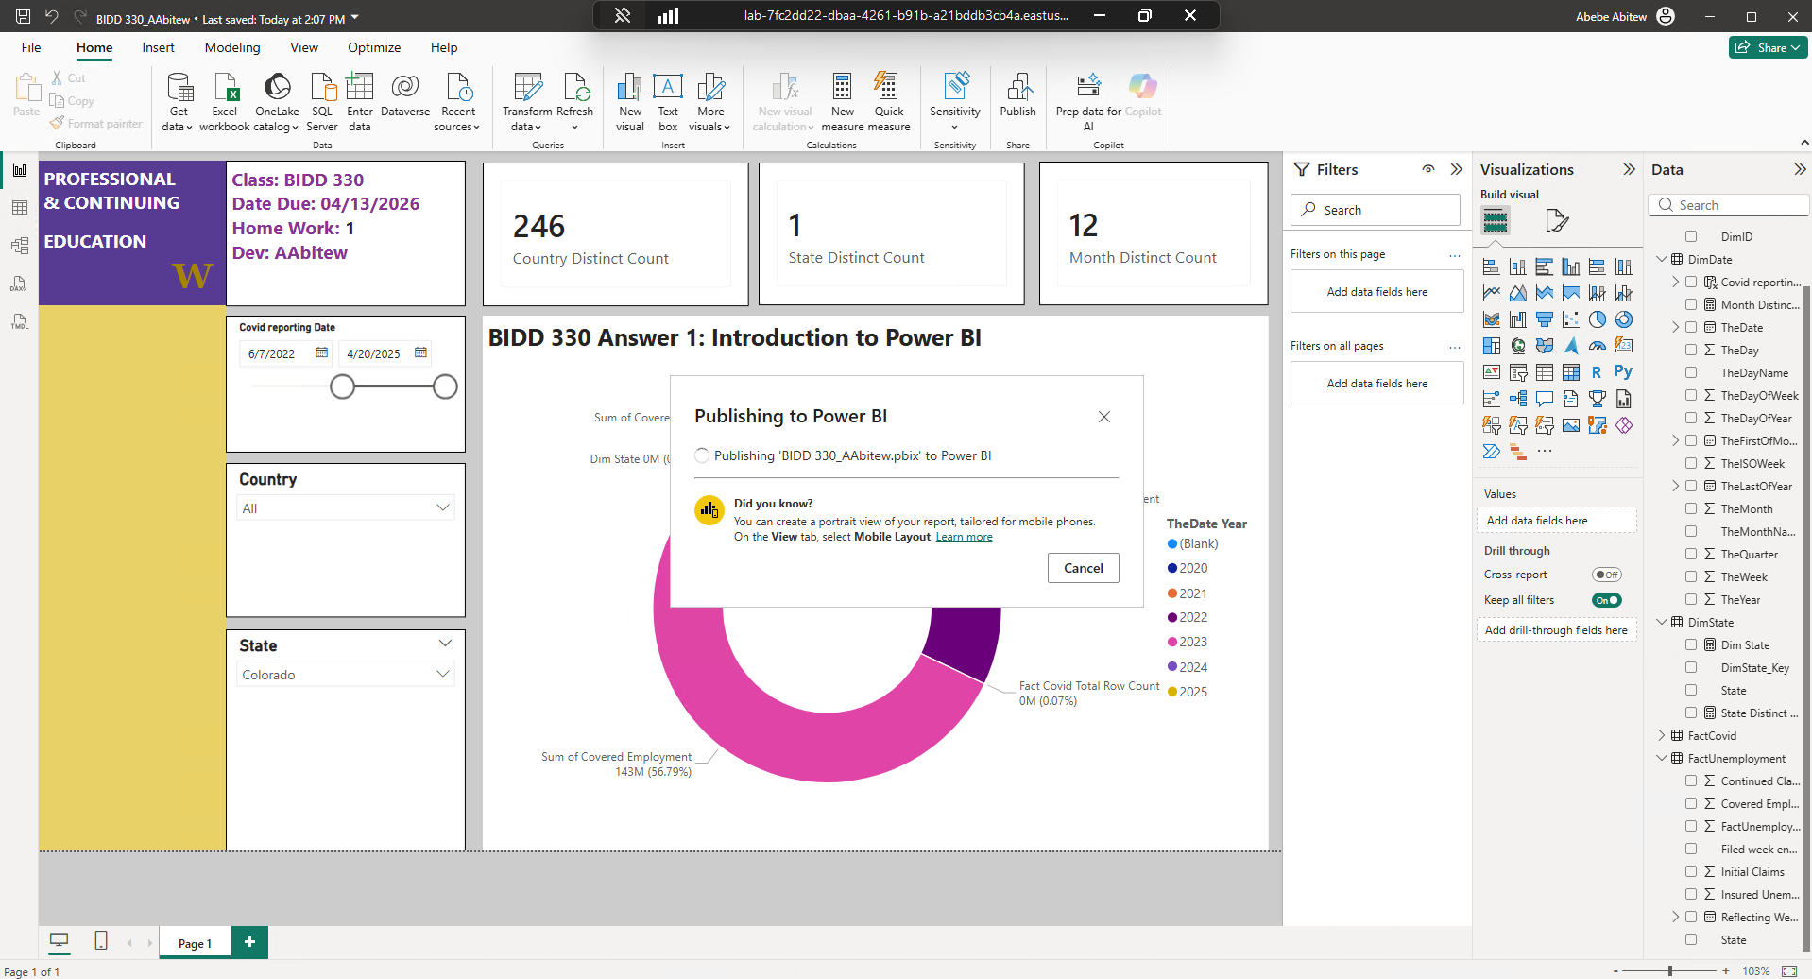

- Published Successfully ( Screenshot)
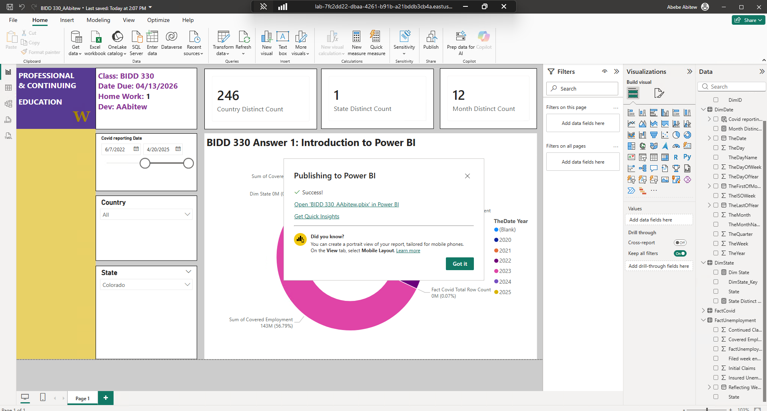

- The link to my Power BI services:
https://app.powerbi.com/groups/777f92d5-bef3-4145-92de-7ca2a66d192b/list?experience=power-bi

